**Some Pie Chart Alternatives**

1. What about something like this to talk about percent of students in each class. The boxes (“Meats”, “Fruits and Vegetables”, “Grains & Baked Goods”) could be the classes and the years (1982, 2012) would be the grade levels (7th grade, 9th grade, 12th grade)

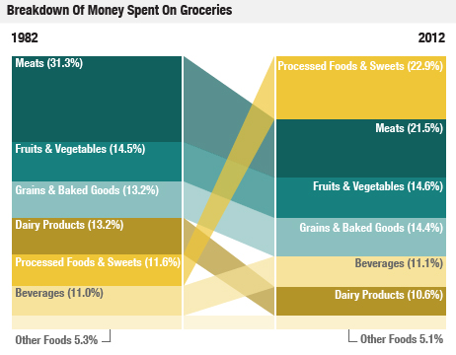

2. Or what about something like this (sometimes referred to as a treemap, nesting, square pie, spine plot, mossiac plot, matrix plot) to talk about differences by gender or ethnicity or gender+ethnicity or something…different squares could be the classes and could have two of these next to each other to compare male/female or something like that.

|  |  |
| --- | --- |
| Males | Females |
| nested-tree | nested-tree |

Or side-by-side instead of nested

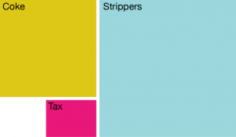

3. Or overlaid area plot to show item profiles for a single year for the different classes.